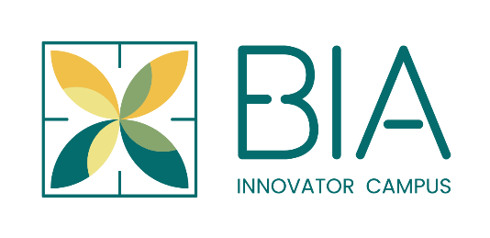
DECEMBER 2020

Welcome to BIA Innovator Campus Food Production Units (BIA Obair) Expression of Interest form.
Return by email to hello@biainnovatorcampus.ie. You are advised to read our BIA Innovator Campus Introduction document before filling out this form.

General Information
- WE WOULD LIKE TO GATHER YOUR CONTACT DETAILS
Name
Company name
Brand name
Your email
Website (if applicable)
Where are you currently based?

Please tell us a little bit about your own background and your food business. When did you start/plan to start? What is special about your product or service?

2. WHICH BEST DESCRIBES YOUR PRODUCT
Consumer food ____ Fresh ____
Dairy ____ Ambient ____
Raw meat ____ Frozen ____
Seafood ____
Other

- ARE YOU CURRENTLY MANUFACTURING? IF SO, PLEASE PROVIDE SOME INFORMATION ON YOUR OPERATION, EQUIPMENT TYPE, CHALLENGES ETC.

Specific interest in BIA Innovator Campus

There are four different options – read and fill out the area that is relevant to you.
- I am registering general interest in the project. Please keep me up to date on developments.

- I am interested in renting a start-up or growth production facility. We require your basic information now so that we can reach out with appropriate responses to you. In your own words please tell us what you would like to do in BIA innovator Campus? Please specify if your interest is in a starter or a growth unit.

- I am interested in using a co-working kitchen (consumer foods, dairy, meat, seafood) on a time share basis. In your own words please tell us what you would like to do in the BIA Obair co-working kitchen (consumer foods, dairy, meat, seafood)?

- I am interested in hosting events/training in BIA Innovator Campus. Do you have an existing event you would like to move to BIA Innovator Campus? Please tell us more

Please provide any further information you think is relevant about your food business plans at this time.

That’s it! You have now completed all sections of the BIA Innovator Campus Expression of Interest form. Email to hello@biainnovatorcampus.ie

Thank you from all the team at BIA Innovator Campus.

